LAB 1 Tech Journal

**Virtual Firewall and Windows 10 configuration**

* Pro tip Draw out Network architecture

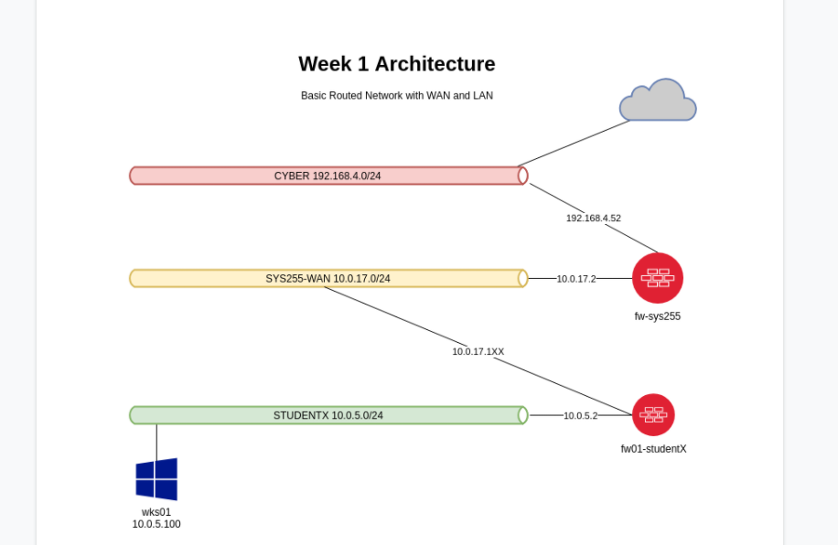

Fw01 = Pfsense = firewall

Wks01 = Workstation

Dhcp01 = DHCP server

Ad01 = Active Directory

The PfSense firewall will provide routing services between a Local Area Network and Wide Area Network in your VSphere environment.

To edit vmware settings right click the vm, click edit settings, then configure your desired setting

Our interfaces should be assigned in the same order as they appeared in our VMWare configuration, namely the WAN should be associated with the first interface and the LAN should be associated with the second interface.

Example of basic commands

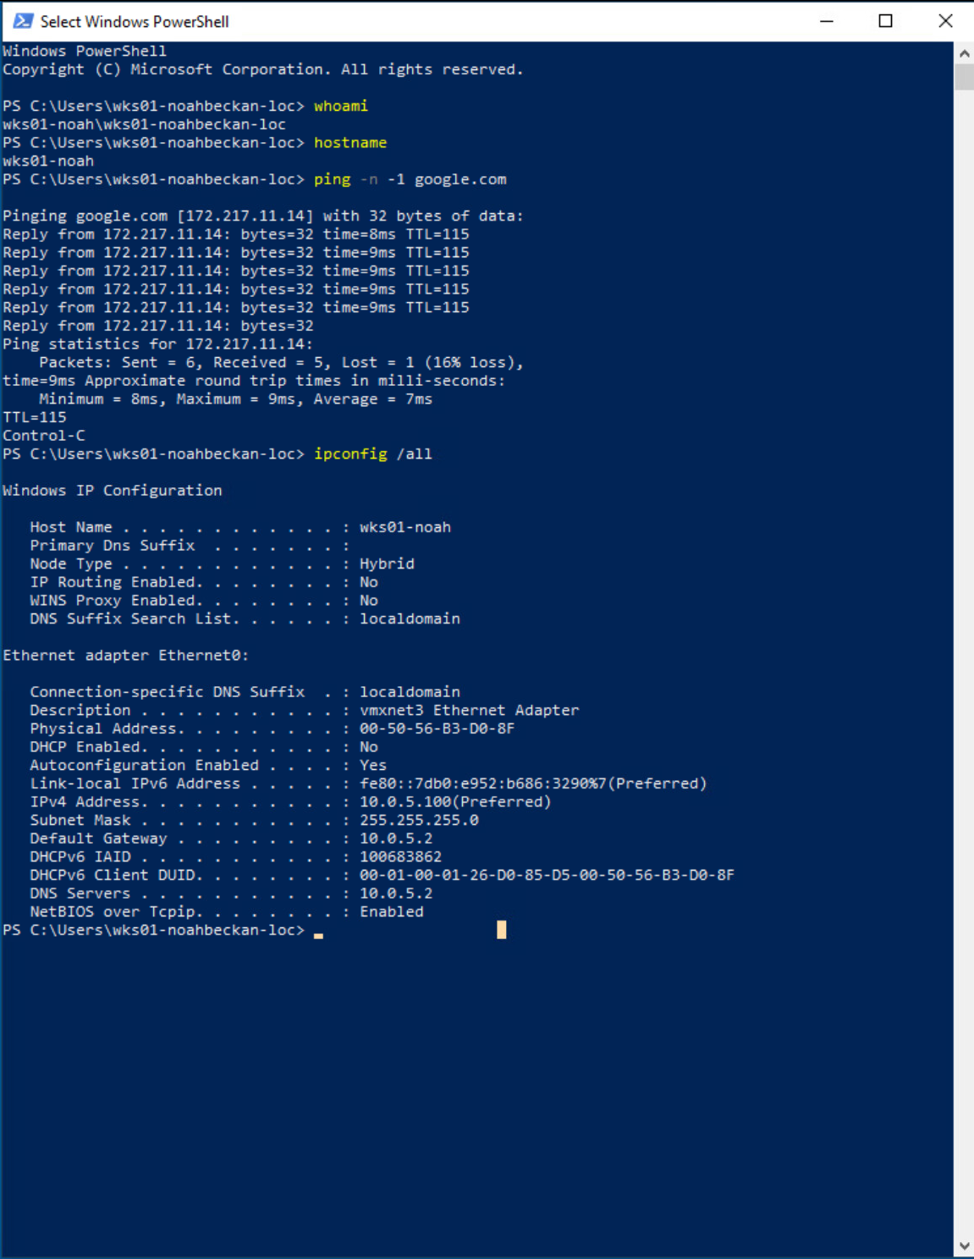

**Difficulties in the lab**

Changing Hostname of computer is just the pc name

* Just change the name of the computer

Be on the correct user when changing users permissions

* Double check the user

Typo in first page of instructions